Computer Vision Lab – Experiment 1
Question 1
Perform basic image handling and processing operations on an image: Read an image in Python and convert the image to Gray-scale.
Aim
To read an image using Python and convert the RGB/color image into a grayscale image.
Requirements
- Python
- OpenCV (cv2)
- Matplotlib (for displaying images)
Program
import cv2
import matplotlib.pyplot as plt
# Read the image
image = cv2.imread("image.jpg")
# Convert the image to grayscale
gray_image = cv2.cvtColor(image, cv2.COLOR_BGR2GRAY)
# Display original image
plt.subplot(1, 2, 1)
plt.imshow(cv2.cvtColor(image, cv2.COLOR_BGR2RGB))
plt.title("Original Image")
plt.axis("off")
# Display grayscale image
plt.subplot(1, 2, 2)
plt.imshow(gray_image, cmap="gray")
plt.title("Grayscale Image")
plt.axis("off")
plt.show()
Explanation
- cv2.imread("image.jpg") reads the image from the specified location.
- cv2.cvtColor() converts the image from BGR to grayscale using cv2.COLOR_BGR2GRAY.
- A grayscale image contains intensity values ranging from 0 (black) to 255 (white).
- matplotlib.pyplot is used to display both the original and grayscale images.
Output
The program displays two images:
- Original Image – the input color image.
- Grayscale Image – the same image converted into shades of gray.
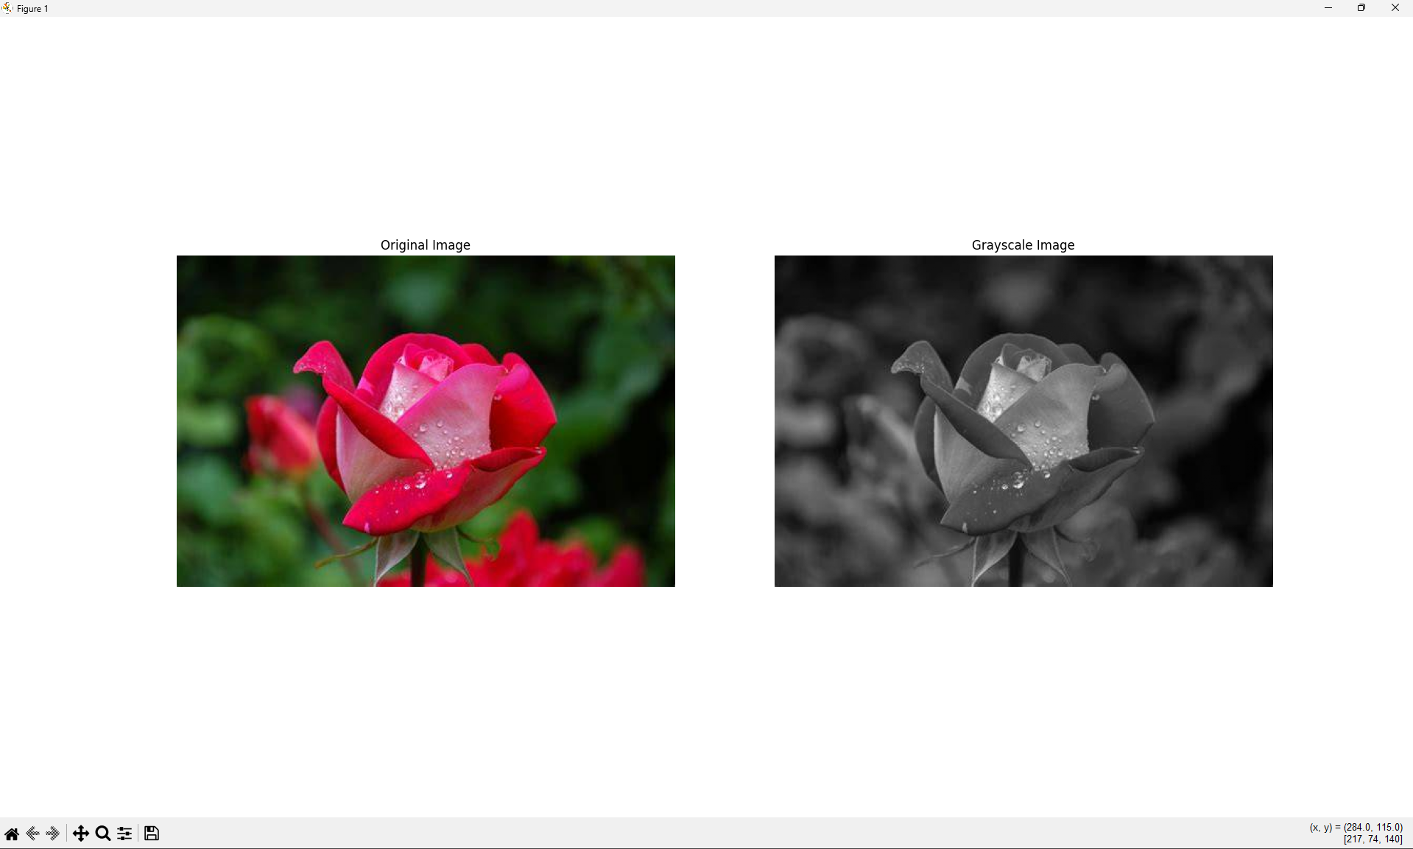
Result
The given color image was successfully read using Python and converted into a grayscale image using OpenCV.

Experiment 2
Question 2
Perform basic image handling and processing operations on an image: Read an image in Python and convert the image to Blur using Gaussian Blur.
Aim
To read an image using Python and apply Gaussian Blur to reduce noise and smooth the image.
Requirements
- Python
- OpenCV (cv2)
- Matplotlib (for displaying images)
Program
import cv2
import matplotlib.pyplot as plt
# Read the image
image = cv2.imread("image.jpg")
# Apply Gaussian Blur
blur_image = cv2.GaussianBlur(image, (15, 15), 0)
# Display original and blurred images
plt.figure(figsize=(10, 5))
plt.subplot(1, 2, 1)
plt.imshow(cv2.cvtColor(image, cv2.COLOR_BGR2RGB))
plt.title("Original Image")
plt.axis("off")
plt.subplot(1, 2, 2)
plt.imshow(cv2.cvtColor(blur_image, cv2.COLOR_BGR2RGB))
plt.title("Gaussian Blurred Image")
plt.axis("off")
plt.show()

Explanation
- cv2.imread("image.jpg") reads the image from the specified location.
- cv2.GaussianBlur() applies a Gaussian Blur effect to the image.
- (15, 15) specifies the size of the Gaussian kernel used for blurring.
- 0 allows OpenCV to automatically calculate the standard deviation.
- matplotlib.pyplot is used to display both the original and blurred images.
- Gaussian Blur smooths the image and helps reduce noise and small unwanted details.
Output
The program displays two images:
- Original Image – the input color image.
- Gaussian Blurred Image – the same image after applying Gaussian Blur.
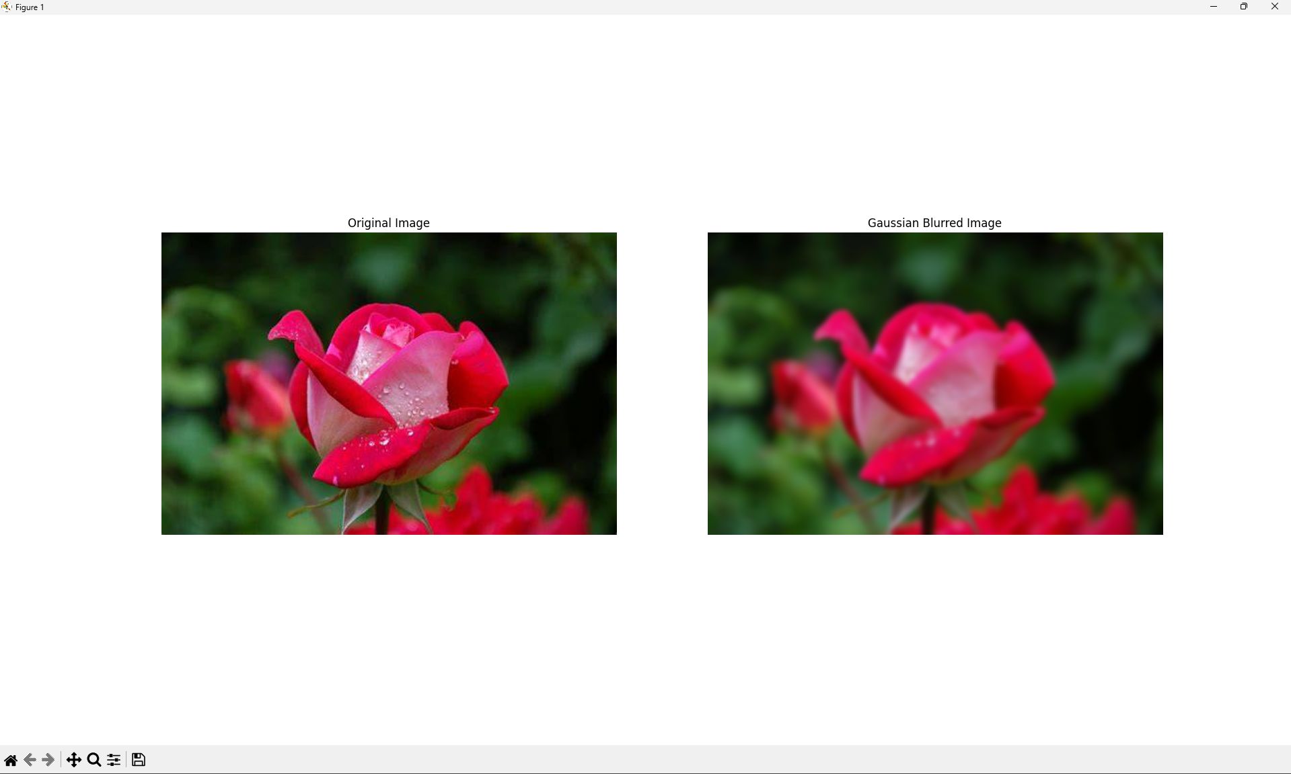
Result
The given image was successfully read using Python and blurred using the Gaussian Blur technique in OpenCV.

Experiment 3
Question 3
Perform basic image handling and processing operations on an image: Read an image in Python and show the outline using the Canny function.
Aim
To read an image using Python and detect the outline/edges of the image using the Canny Edge Detection technique.
Requirements
- Python
- OpenCV (cv2)
- Matplotlib (for displaying images)
Program
import cv2
import matplotlib.pyplot as plt
# Read the image
image = cv2.imread("image.jpg")
# Convert the image to grayscale
gray_image = cv2.cvtColor(image, cv2.COLOR_BGR2GRAY)
# Detect edges using Canny function
canny_image = cv2.Canny(gray_image, 100, 200)
# Display original and Canny edge images
plt.figure(figsize=(10, 5))
plt.subplot(1, 2, 1)
plt.imshow(cv2.cvtColor(image, cv2.COLOR_BGR2RGB))
plt.title("Original Image")
plt.axis("off")
plt.subplot(1, 2, 2)
plt.imshow(canny_image, cmap="gray")
plt.title("Canny Edge Image")
plt.axis("off")
plt.show()
Explanation
- cv2.imread("image.jpg") reads the image from the specified location.
- cv2.cvtColor() converts the color image into a grayscale image.
- cv2.Canny() detects the edges/outlines present in the image.
- 100 is the lower threshold and 200 is the upper threshold used by the Canny edge detector.
- matplotlib.pyplot is used to display the original image and the detected edges.
- The Canny function produces an image where the detected edges are generally shown in white on a black background.
Output
The program displays two images:
- Original Image – the input color image.
- Canny Edge Image – the outline/edges detected from the image.
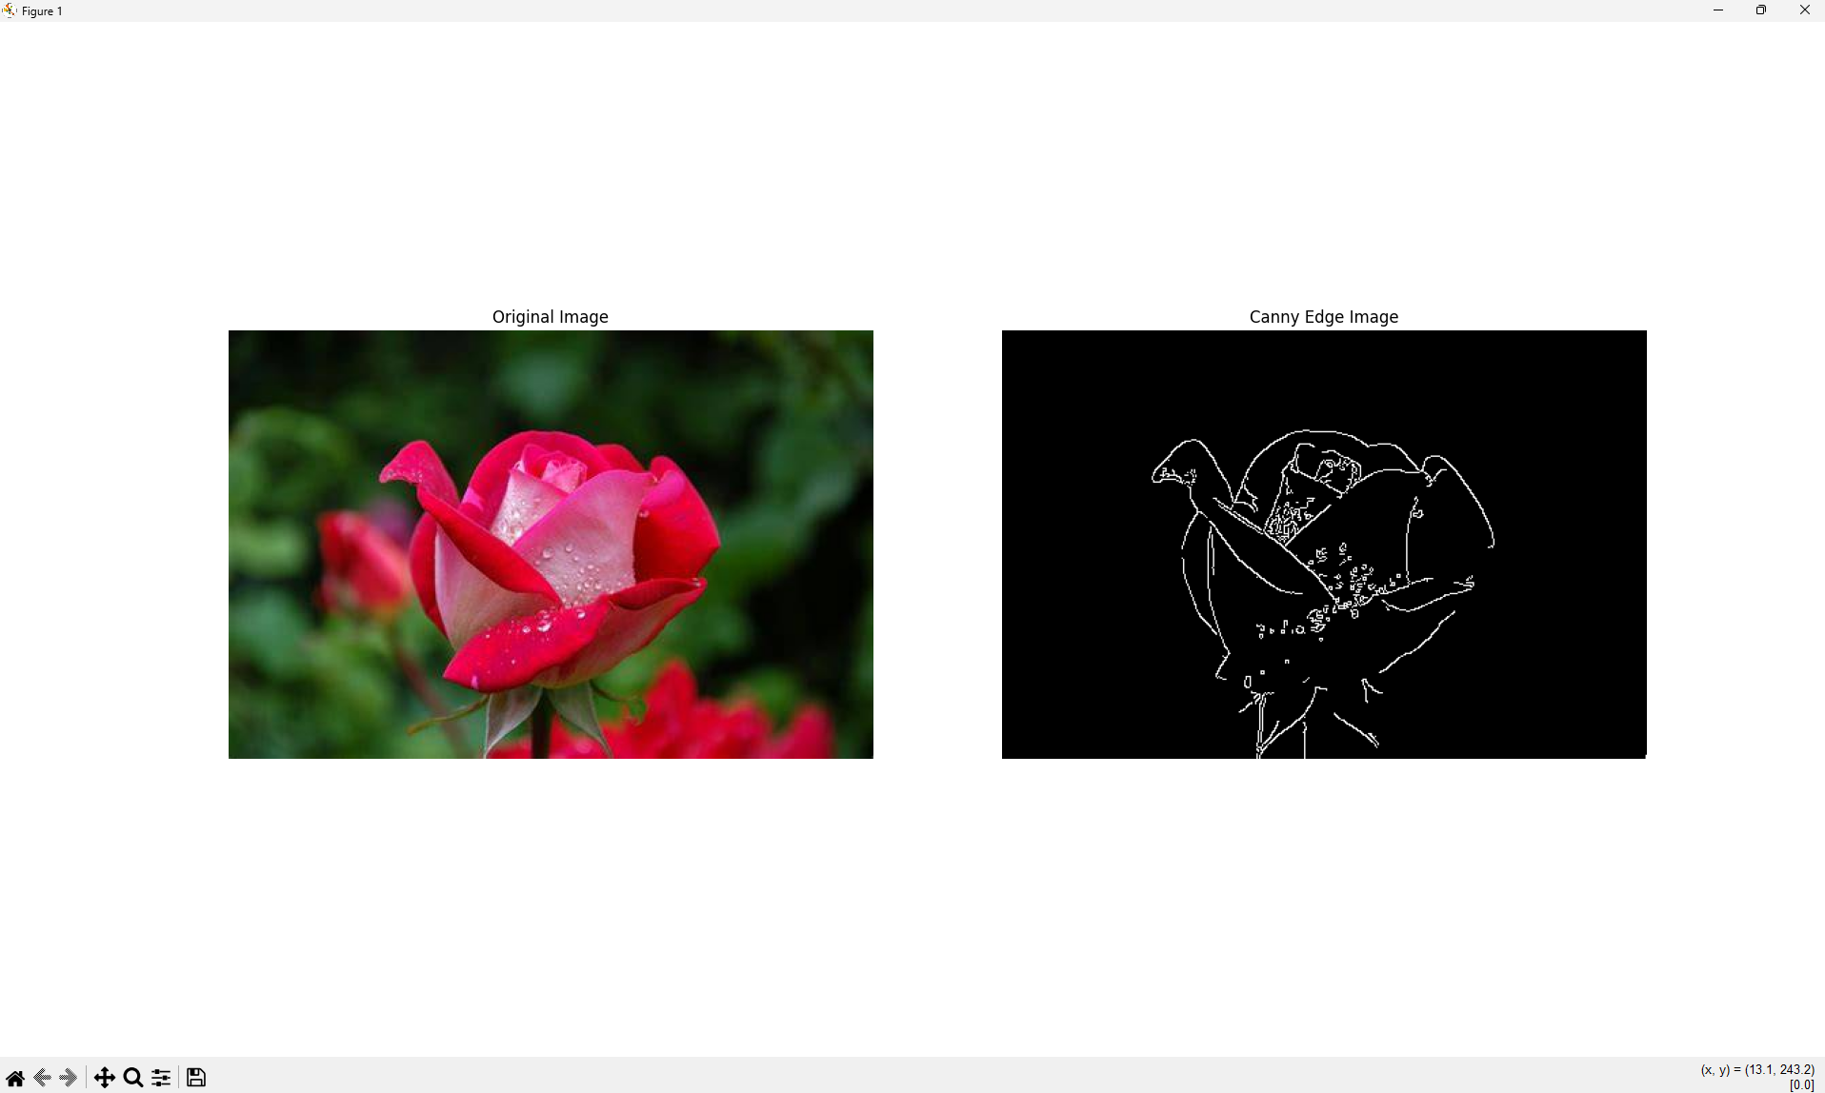
Result
The given image was successfully read using Python and its outlines/edges were detected using the Canny edge detection technique.
Experiment 4
Question 4
Implement histogram equalization on the given image and compare it with the original image using OpenCV.
Aim
To perform Histogram Equalization on a given image using OpenCV and compare the equalized image with the original image.
Requirements
- Python
- OpenCV (cv2)
- Matplotlib (for displaying images)
Program
import cv2
import matplotlib.pyplot as plt
# Read the image
image = cv2.imread("image.jpg")
# Convert the image to grayscale
gray_image = cv2.cvtColor(image, cv2.COLOR_BGR2GRAY)
# Apply histogram equalization
equalized_image = cv2.equalizeHist(gray_image)
# Display original grayscale and equalized images
plt.figure(figsize=(12, 8))
plt.subplot(2, 2, 1)
plt.imshow(gray_image, cmap="gray")
plt.title("Original Grayscale Image")
plt.axis("off")
plt.subplot(2, 2, 2)
plt.imshow(equalized_image, cmap="gray")
plt.title("Histogram Equalized Image")
plt.axis("off")

# Display histogram of original image
plt.subplot(2, 2, 3)
plt.hist(gray_image.ravel(), 256, [0, 256])
plt.title("Original Histogram")
plt.xlabel("Intensity")
plt.ylabel("Frequency")
# Display histogram of equalized image
plt.subplot(2, 2, 4)
plt.hist(equalized_image.ravel(), 256, [0, 256])
plt.title("Equalized Histogram")
plt.xlabel("Intensity")
plt.ylabel("Frequency")
plt.tight_layout()
plt.show()
Explanation
- cv2.imread("image.jpg") reads the given image.
- cv2.cvtColor() converts the color image into a grayscale image.
- cv2.equalizeHist() performs histogram equalization on the grayscale image.
- Histogram equalization improves the contrast of an image by redistributing its intensity values.
- plt.hist() displays the histogram of the original and equalized images.
- The original and equalized images are displayed side by side for comparison.
Output
The program displays four results:
- Original Grayscale Image – the original image converted to grayscale.
- Histogram Equalized Image – the image after improving its contrast.
- Original Histogram – intensity distribution before equalization.
- Equalized Histogram – intensity distribution after equalization.
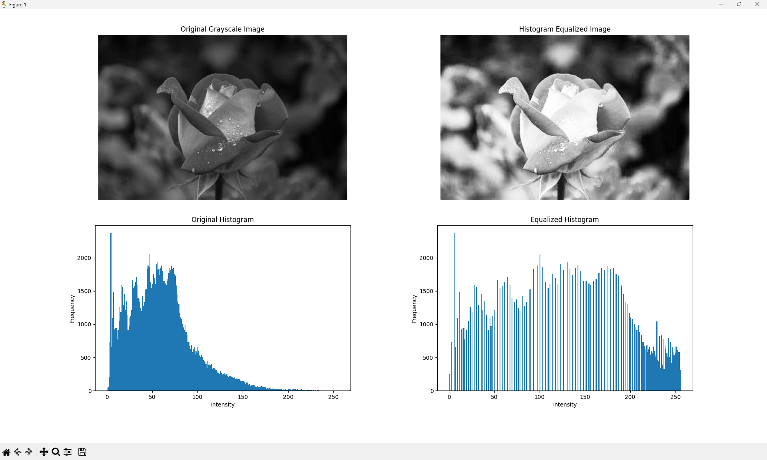
Result
The histogram of the given image was successfully equalized using OpenCV, and the original grayscale image was compared with the histogram-equalized image. The equalized image shows improved contrast compared with the original image.

Experiment 5
Question 5
Write a Python function to analyze the histogram of the given input image based on color levels using OpenCV.
Aim
To write a Python function to analyze and display the color histogram of a given input image using OpenCV.
Requirements
- Python
- OpenCV (cv2)
- Matplotlib (for displaying the histogram)
Program
import cv2
import matplotlib.pyplot as plt
# Function to analyze the color histogram
def analyze_histogram(image_path):
# Read the image
image = cv2.imread(image_path)
# Convert BGR image to RGB
image_rgb = cv2.cvtColor(image, cv2.COLOR_BGR2RGB)
# Calculate histograms for Red, Green and Blue channels
red_hist = cv2.calcHist([image], [2], None, [256], [0, 256])
green_hist = cv2.calcHist([image], [1], None, [256], [0, 256])
blue_hist = cv2.calcHist([image], [0], None, [256], [0, 256])
# Display the original image
plt.figure(figsize=(12, 5))
plt.subplot(1, 2, 1)
plt.imshow(image_rgb)
plt.title("Original Image")
plt.axis("off")
# Display the color histogram
plt.subplot(1, 2, 2)
plt.plot(red_hist, label="Red")
plt.plot(green_hist, label="Green")
plt.plot(blue_hist, label="Blue")
plt.title("Color Histogram")
plt.xlabel("Color Level")
plt.ylabel("Number of Pixels")
plt.legend()
plt.tight_layout()
plt.show()
# Call the function
analyze_histogram("image.jpg")
Explanation
- cv2.imread("image.jpg") reads the given input image.
- OpenCV reads a color image in BGR order: Blue, Green and Red.
- cv2.cvtColor() converts the BGR image to RGB so that Matplotlib displays the colors correctly.
- cv2.calcHist() calculates the histogram for each color channel.
- The histogram contains 256 color levels, from 0 to 255.
- red_hist, green_hist, and blue_hist store the pixel frequency for each color level.
- plt.plot() displays the three color histograms.
- The analyze_histogram() function can be reused with different image files.
Output
The program displays:
- Original Image – the input color image.
- Color Histogram – three histogram curves representing:
  - Red color levels
  - Green color levels
  - Blue color levels
The horizontal axis represents color intensity levels from 0 to 255, while the vertical axis represents the number of pixels at each intensity level.
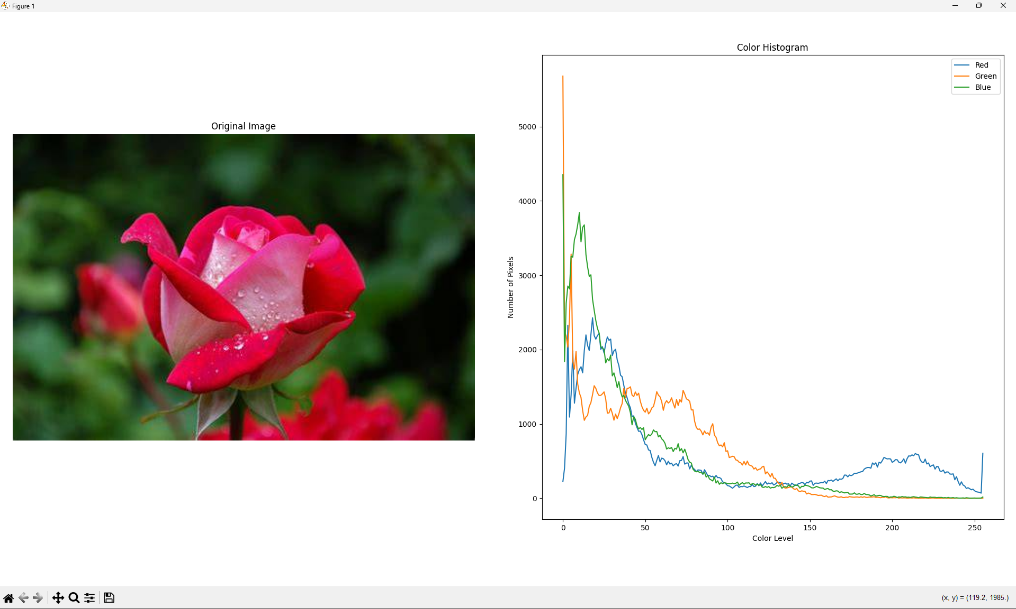
Result
The Python function was successfully implemented to analyze the color-level histogram of the given input image using OpenCV.

Experiment 6
Question 6
Perform basic image handling and processing operations on an image: Read an image in Python and convert an image to erode using the Erode function.
Aim
To read an image in Python and perform image erosion using the OpenCV cv2.erode() function.
Requirements
- Python
- OpenCV (cv2)
- Matplotlib
- VS Code
- Input image (image.jpg)
Program
import cv2
import matplotlib.pyplot as plt
# Read the image
image = cv2.imread("image.jpg")
# Convert the image to grayscale
gray_image = cv2.cvtColor(image, cv2.COLOR_BGR2GRAY)
# Create a kernel
kernel = cv2.getStructuringElement(cv2.MORPH_RECT, (5, 5)
# Apply erosion
eroded_image = cv2.erode(gray_image, kernel, iterations=1)
# Display original and eroded images
plt.figure(figsize=(10, 5))
plt.subplot(1, 2, 1)
plt.imshow(gray_image, cmap="gray")
plt.title("Original Grayscale Image")
plt.axis("off")

plt.subplot(1, 2, 2)
plt.imshow(eroded_image, cmap="gray")
plt.title("Eroded Image")
plt.axis("off")
plt.tight_layout()
plt.show()
Explanation
- Read the image
image = cv2.imread("image.jpg")
The cv2.imread() function reads the input image.
- Convert to grayscale
gray_image = cv2.cvtColor(image, cv2.COLOR_BGR2GRAY)
The image is converted from a color image to a grayscale image.
- Create a kernel
kernel = cv2.getStructuringElement(cv2.MORPH_RECT, (5, 5))
A 5 × 5 rectangular kernel is created. The kernel is used by the erosion operation to examine neighboring pixels.
- Apply erosion
eroded_image = cv2.erode(gray_image, kernel, iterations=1)
The cv2.erode() function performs erosion on the image.
- Display the images
The original grayscale image and the eroded image are displayed side by side using Matplotlib.
What is Image Erosion?
Erosion is a morphological image processing operation that makes the bright/white regions of an image smaller or thinner.
It is commonly used to:
- Remove small white noise
- Separate objects that are connected
- Reduce the size of foreground objects
- Remove small unwanted details
- Refine object boundaries
The size and shape of the kernel affect the amount of erosion.
For example:
(5, 5)
means a 5 × 5 kernel is used.
Increasing the kernel size generally produces a stronger erosion effect.
Output
The program displays two images:
- Original Grayscale Image
- Eroded Image
The white/bright regions in the eroded image will generally appear thinner or smaller compared with the original image.
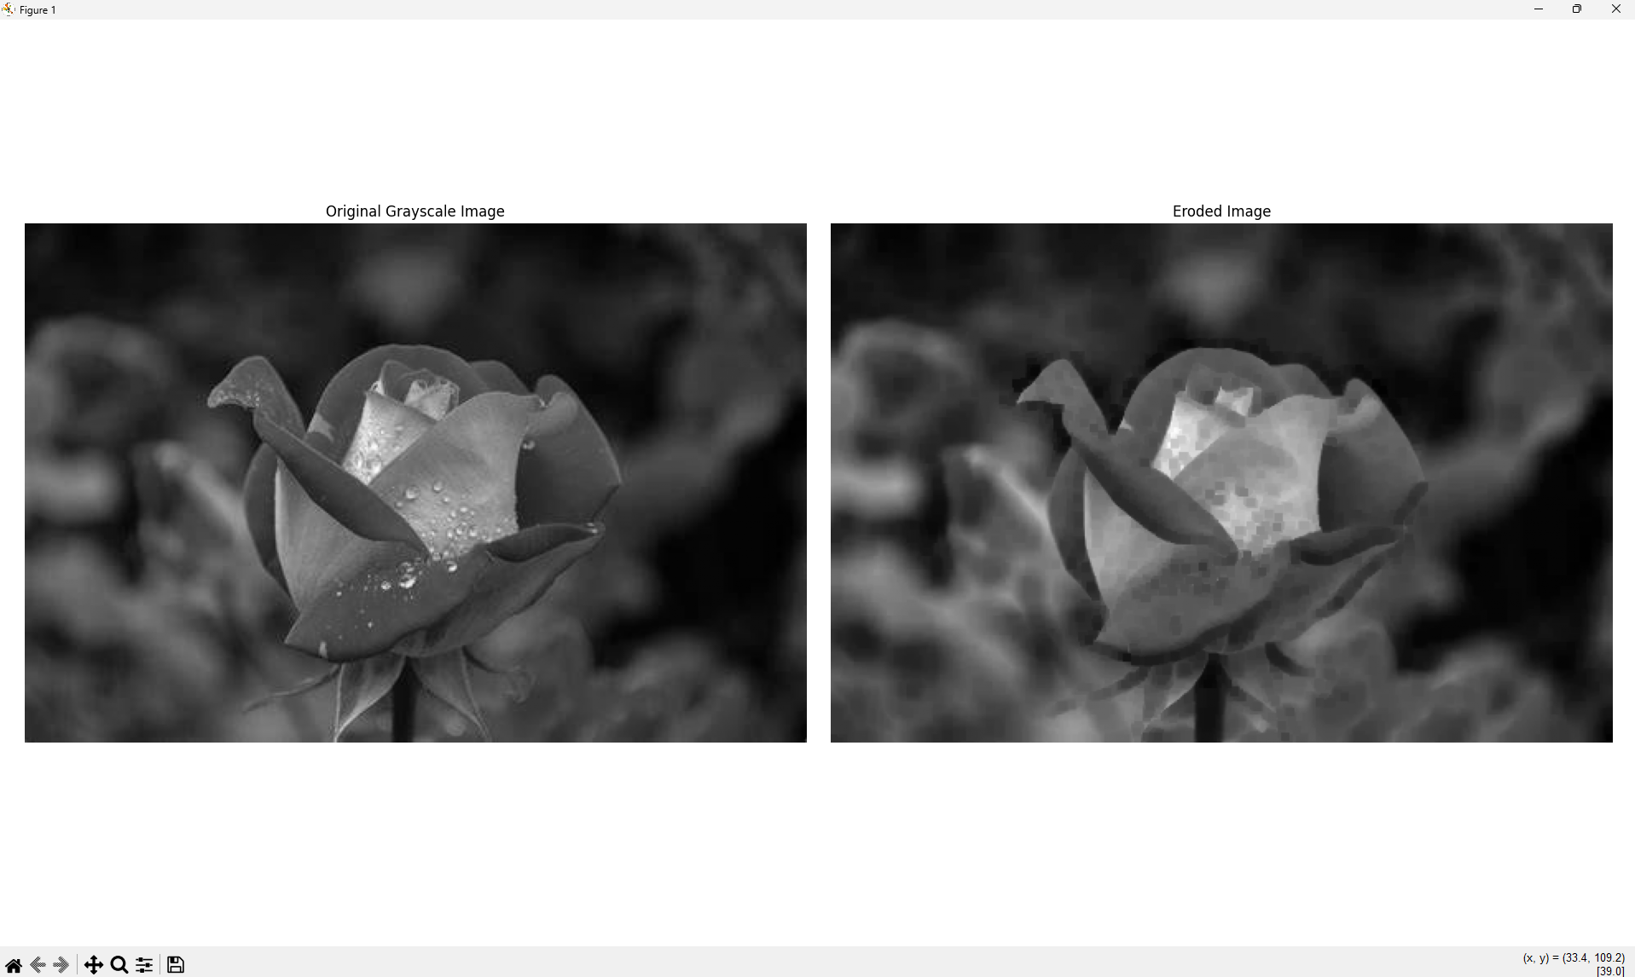
Result
Thus, the given image was successfully read using Python and image erosion was performed using the OpenCV cv2.erode() function.

